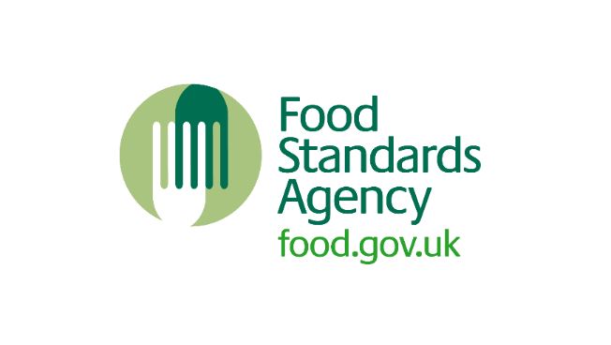

# Register a Food Business Checklist

**This checklist is to be used alongside information available on FSA business guidance pages.**

|  |  |
| --- | --- |
| **Task** | **Completed** |
| **I have a business plan** |  |
| **I have registered my food business with my Local Authority** |  |
| **I have the required permissions and insurance to run my food business** |  |
| **I have decided what type of business I am: a sole trader/ limited company/ operate in partnership/ charity** |  |
| **I have considered HMRC tax implications for my business (if required)** |  |
| **I have conducted a risk assessment of my food business** |  |
| **I have food safety management procedures in place** |  |
| **I have considered food safety training/ food hygiene qualifications** |  |
| **My premise/ home is in good repair and condition to run my food business** |  |
| **I am aware of allergen information and will follow labelling rules as set out in food law** |  |
| **I am aware of the legal requirements and safety considerations when providing food online** |  |
| **I have up to date records of suppliers that provide my ingredients and businesses I may supply food to** |  |
| **I understand what a food hygiene inspection involves** |  |

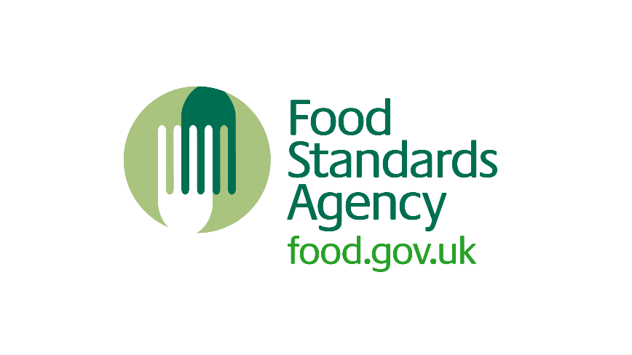  
  
  
© Crown copyright 2022

This publication (not including logos) is licensed under the terms of the Open Government Licence v3.0 except where otherwise stated. Where we have identified any third party copyright information you will need to obtain permission from the copyright holders concerned.

For more information and to view this licence:

* visit [the National Archives website](http://www.nationalarchives.gov.uk/doc/open-government-licence/version/3/)
* email [psi@nationalarchives.gov.uk](mailto:psi@nationalarchives.gov.uk)
* write to: Information Policy Team, The National Archives, Kew, London, TW9 4DU

For enquiries about this publication, [contact the Food Standards Agency](https://www.food.gov.uk/contact/businesses/find-details).

Twitter logo Follow us on Twitter: [@foodgov](https://twitter.com/foodgov)

 Find us on Facebook: [facebook.com/FoodStandardsAgency](http://www.facebook.com/FoodStandardsAgency)