You must print all the mandatory information using a font with a minimum x-height of 1.2 millimetres.
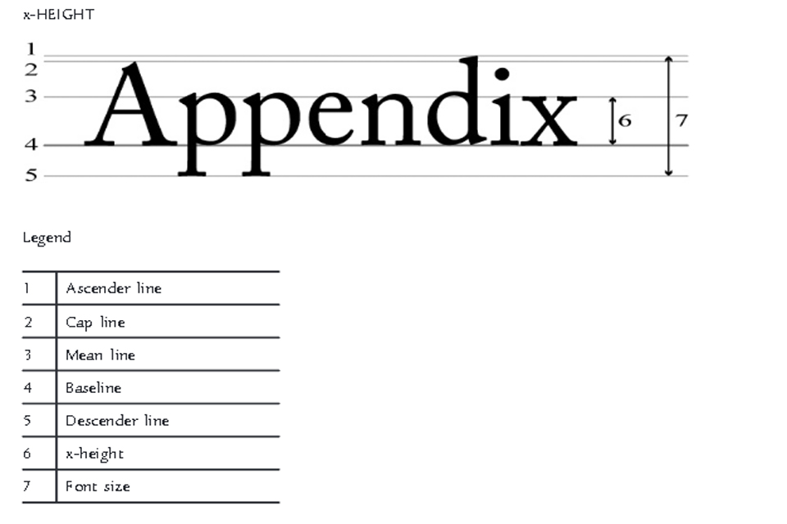
The x-height (6) must be 1.2 millimetres
If the largest surface area of packaging is less than 80cm squared, you can use a minimum x-height of 0.9mm.

